Answers Bible Curriculum – Digging Deeper (Lesson 33)

Last week we looked at the life of Job. We saw how God brought trials into Job’s life through the actions of Satan. Job lost his ten children and almost all of his possessions. Then his body was covered with boils.

Job was visited by three friends who tried to comfort him in his trials. How did Job’s comforters misrepresent God’s character and Job’s trials? They accused Job of sinning, and they believed that God would bring these trials to Job only in response to his sin. They failed to recognize that bad things often happen to those who are following God.
We also read from Romans 8 and saw that, in the context of trials, God works all of those situations together for good for his children. Ultimately, we are being transformed into the image of Christ, which will have its final fulfillment when we see him face to face in glory. We should be comforted in knowing that a wise, loving, sovereign Creator God is holding us in his hands.
Today, we are going to look at someone who was a contemporary of Job. We are going to look at Abram in the next four lessons.

How does God reward faith and obedience?
How did Job respond to the trials he was facing? Job recognized that God had given him his possessions and that God had taken them away. Rather than cursing God, Job worshipped God because he understood God rightly.

Abram was alive about the same time as Job. If you remember from our lesson on the age of the earth, Abram lived right between Adam and Christ—about 2,000 years after Adam and about 2,000 years before Christ. An interesting note about Abram is that he was alive during Shem’s lifetime, about 350 years after the flood.

Read Genesis 11:27–12:9:
- Who are Abram’s relatives mentioned in this passage? Terah, his father; Nahor and Haran, his brothers; Lot, his nephew; Milcah, his sister-in-law; Sarai his wife.
- What do we learn about Sarai in verse 30? She was barren, unable to have children.
- Where did Terah and his family travel from and to? They began in Ur of the Chaldeans and settled in Haran.
- What was the intended final destination? The land of Canaan.
- Where have we heard of Canaan before? He was one of the grandsons of Noah mentioned in Genesis 10:6 and 15 as one of the sons of Ham.
- Why were they traveling to Canaan? God had told Abram to leave his country and his family and travel to a land he would show him.
- Did Terah make it to Canaan? No, he died in Haran at the age of 205.
- Describe the promises God made to Abram in 12:1–3. God would make him a great nation, bless him, make his name great, make him a blessing, bless/curse those who blessed/cursed him, and bless all families of the earth in him.
- What additional promise was given to Abram in verse 7? The land of Canaan would be given to his descendants.
- How old was Abram when he left Haran? 75.
- Who went into Canaan? Abram, Sarai, Lot, and all of their servants.
- How did Abram demonstrate his faith in God’s words? According to Genesis 12:4, he left just as God told him to do.
- Where did God appear to Abram once he was in Canaan? Near Shechem.
- What did he do after reaching the land? He built an altar to the Lord.
- Did Abram stay in Shechem? No, he moved to the area between Bethel and Ai, where he built another altar, and then moved south.
- What is the main point of the passage? Abram was called by God to leave his home and family to become the beginning of a great nation. Abram obeyed God in going to Canaan.

Discover The Truth
Now that we have asked questions about the text, let’s look at a map of Abram’s journey so far: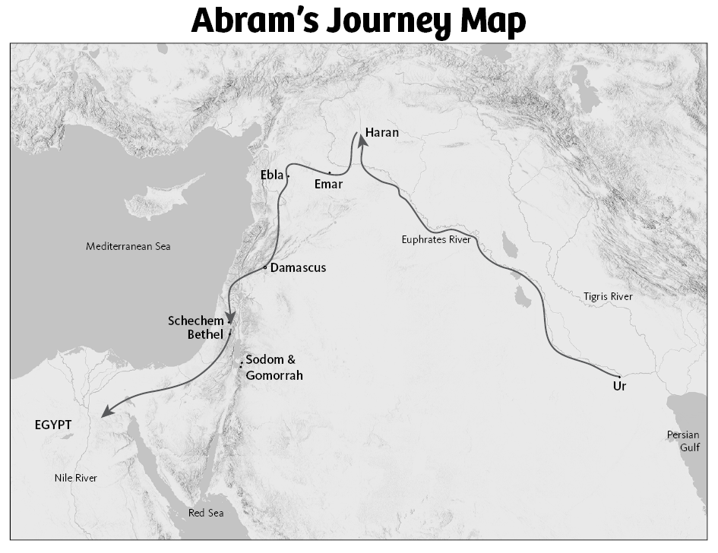

Abram traveled with his father and Lot from Ur to Haran, about 600 miles, likely along the Euphrates River. It seems they stayed in Haran for some time, though it is hard to tell how long from the text. After Terah died, Abram and Lot headed south toward Canaan, about 400 miles, stopping in Shechem and then moving on to Bethel, about 20 miles away. After this, there was a famine, and they continued south toward Egypt. Eventually they returned to Canaan—but we will get to that later. We know from archaeological excavations of the city of Ur that it was a city centered on the idolatrous worship of Nanna-Sin, the moon god. Abram was called out of this culture to become the founder of the Israelite people who would build a culture that worshipped God rightly.
- What other information do we learn about the relationship between Sarah and Abraham in Genesis 20:12? She was his half-sister by a different mother.

This came into play later in chapter 12 when Abram told Sarai to tell the people of Egypt that she was simply his sister—which was true, but not the whole truth. This is one demonstration of the truthfulness of the Bible. Rather than covering up all of the flaws of the “heroes” in the Bible, their sins are exposed, and we learn how God used people like Abram despite their problems. If God used only perfect people, he wouldn’t get anything accomplished through men. Despite Abram’s shortcomings, his faith in God was ultimately evident by his obedience.

Now look at Hebrews 11:8–16.
Keep in mind that this chapter of Hebrews is often referred to as the Hall of Faith. It tells of saints throughout history who have had great assurance of their salvation by faith in God’s promises.
You might also notice that we are now talking about Abraham rather than Abram since God changed his name.
- How was Abraham able to obey God? By faith.
- Did Abraham know where he was going to settle when he left Ur? No.
- How was Abraham able to live in tents in the land of promise? By faith.
- Who are Isaac and Jacob? Isaac is Abraham’s son, and Jacob is Isaac’s son.
- What was Abraham waiting for as he was dwelling in tents? He was waiting for a city built by God.
- Did Abraham receive the promises of God while he was alive? He did not receive the promises, but trusted by faith that God was faithful and would fulfill them.
- How did Abraham view his time on earth? He saw himself as a stranger and exile on the earth, looking forward to a future city.
- What do we learn about the promise to make Abraham a great nation? From Abraham came descendants in number like the stars of heaven and the sands of the seashore. This is foreshadowing that we will discuss in a future lesson.
- What phrase is repeated through this passage? By faith.
- What does the passage tell us about God? God is the builder and maker of the city (heaven), and he is not ashamed to give it to those who have faith.
- What is meant by “the land of promise”? This is a reference to the land of Canaan that was promised to Abram.
- What is the city referred to in verse 10? As verse 16 also states, this is a heavenly city, not a worldly place.
- Why is Abram referred to as Abraham? God had changed his name (Genesis 17:5).
- What did Abraham view as his homeland? Even though God had promised the land of Canaan to his descendants, Abraham was looking forward to heaven and trusting that God was faithful to deliver on that promise.
Read Matthew 6:19-21
Jesus talks about the relationship between our money and our hearts in Matthew 6:19–21.
- How does Abraham reflect this attitude? Based on the information we have in the Hebrews passage, he did not focus on building his own earthly kingdom, but on a future heavenly kingdom.
Rather than looking for material blessings on earth and having a kingdom established that he could reign over, Abraham saw himself as a pilgrim. He trusted God to fulfill his promises, but he never actually saw those promises fulfilled. This is a great example of faith for us to follow. Just as Abraham had assurance that God was faithful to honor his promises, we can have that same assurance by faith.

A Heavenly Hope:
Take a few minutes to stop and think about the ideas of faith and obedience and consider where you are placing your hope:
1.From Hebrews 11:1, write a biblical definition for faith.

2. Below is a list of events in Abraham’s life that demonstrate his faith through his obedience to God. Some of these will be discussed in later lessons, and some we have discussed today. Next to each item, try to identify a similar situation in your life in which you have demonstrated, or may someday demonstrate, your faith:
• Leaving his home and family for an unknown country

• Building an altar to worship God

• Offering Lot the choice of land to live in

• Waiting for a son to fulfill God’s promise

• Offering Isaac, the son of promise, as a sacrifice

3. How does Abraham embody the instructions in Colossians 3:1–5?

4. What things here on earth have you set your hope on?

5. What would need to change about your lifestyle if you were to act as a “stranger and pilgrim” here on this earth?

6. If we are going to trust God to fulfill his promises, why is an understanding of God’s faithfulness important?

Connect to the Truth
Thinking through issues like these can raise lots of questions. Hopefully, we are not just learning from Scripture so that we can know more, but so that we can grow and change to be more like Christ. The Colossians passage that you read calls us as Christians to set our minds on heavenly things rather than on things here on earth.

In what ways is Abraham a role model for us in this matter? Abraham understood that God’s promise would be fulfilled, but he looked forward to the hope of heaven rather than the establishment of an earthly kingdom. He focused on heavenly things, not on building his own earthly kingdom.

As Christians, we should not place our hope or the focus of our activities on earthly things, but on heavenly things. God’s riches for us are not found in earthly treasures but in the salvation that we have in Christ. In Ephesians 1, Paul calls us to recognize the inheritance that we have through the grace of God. Abraham recognized this same idea in God’s promises—his hope was in dwelling with God after he died, not merely in his temporary existence on earth.

Application
Think about what we read about Abraham. We see his faith and that he was looking forward to the hope of heaven. He exercised his faith in his obedience to leave his homeland. And in the next several lessons, we will see how he continued to obey God in faith.

Let us make sure that we think of how we can apply these ideas as we leave and go out into the world we live in. We want to make sure that we are not merely hearing the Word, but seeking to be doers of what we read in it.
- We know that God has promised to reward those who place their faith in him. When can we expect to receive those rewards? While we may receive blessings here on earth, we should not expect them or focus on them. Many believers across the globe face great persecution and the loss of property and life; their hope must be fixed on heaven. Most of us have lost sight of these truths in our prosperous situations in the West.
- Have you ever heard the expression “you are so heavenly minded that you are no earthly good”? Is this a biblically grounded idea in light of what we have been studying today? Unless it involves locking yourself in a monastery, which really isn’t being “heavenly minded,” being focused on heavenly things is the goal of believers. As we understand more about the things of God, we will be moved to respond to God’s call to serve him and those around us. Being heavenly minded will lead to our working to build God’s Kingdom with the expectation of an eternity with him in heaven.
- Why is it so important to understand God’s attribute of faithfulness as we seek to follow him in faith? Without knowing that God’s character includes perfect faithfulness, we might doubt that God will actually keep his promises. Yet Scripture is full of examples, like Abraham, to assure us of the truth of his faithfulness.
- How does the world react to the idea of storing up treasures in heaven rather than seeking to build fortunes and seeking pleasures here on earth? Most in the world are seeking their own gain, and to tell them otherwise would be quite radical.
- In what ways are you failing to set your mind on things above? How can you seek to change this attitude? Remember that it is only by God’s grace and trusting in his faithfulness that we can accomplish such things.
- As you seek to live your life with a focus on heavenly things, how might you be viewed by unbelievers? How can this be a launching pad from which you can share the gospel? Remember that as we live lives of distinction, we will have opportunities to share the gospel, the source for our hope of heaven. We can also expect to face persecution for our firm stand on the Bible and our trust in Jesus.

